Marble Game

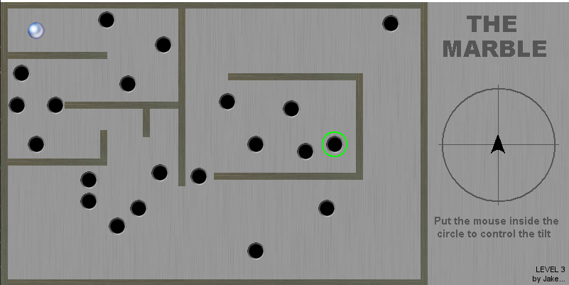

Issues and Achievements

Collisions with the walls.

When I was implementing the wall collisions, I had forgotten that I needed to check the collisions for the top, bottom, left, and right separately. I had only implemented the collisions for the top of a wall, so when I collided with the sides the marble went out of bounds.

Level design

When designing the level, I was struggling to visualise where the coordinates would display the holes and walls on the screen. I decided to return the coordinates of the cursor when I pressed the right mouse button. First, I tried to use cout to return the coordinates but found that no console window opened, so instead of using cout I decided to change the value of the strInfo2 variable that holds the name of the level designer.

